**Candidate Information**

|  |  |
| --- | --- |
| *Full Name* | Trevor McCaffrey |
| *Current Year* | Junior |
| *Degree Program(s) & Graduation Year* | BS Physics 2023 |
| *Minor(s)* |  |
| *GPA* | 3.96 |
| *Transfer Student?* | No |
| *Field of Study/Subfield (*[*Judging Category*](https://goldwaterscholarship.gov/wp-content/uploads/2019/09/Fields-of-Study.pdf)*)* | Physics and Astronomy – Astronomy & Astrophysics |
| *Specific Questions for Reviewers:* | The following questions relate to specific challenges faces by this candidate in preparing their application; we would appreciate your input on these via the “general comments” section of the review form.   * The candidate’s research essay describes several closely related projects; normally, we would encourage the candidate to focus on just one project so they can use their limited space to provide all of the description and reflection requested in [the prompt](https://goldwaterscholarship.gov/developing-the-research-essay/). However, including both projects does allow the candidate to more clearly express the significance of their findings to major questions in the field. Based on this draft of the research essay, do you think it is better to retain the briefer explanations of both projects, or do you think the candidate should focus on just one—and if so, which one? |

**Career Goals and Professional Aspirations**

|  |  |
| --- | --- |
| *What is the highest degree you plan to obtain?* | Ph.D. |
| *In one or two sentences, describe your career goals and professional aspirations. (200 characters)* | Ph.D. in Astronomy. I hope to lead my own research lab on how black holes affect host galaxies, while teaching at the university level. |

|  |
| --- |
| *What are your career goals and professional aspirations? Indicate which area(s) of mathematics, science, or engineering you are considering pursuing in your research career and specify how your current academic program and your overall educational plans will assist you in achieving your career goals and professional aspirations. (3000 characters)* |
| I aim to become a university professor performing astronomical research. I am most interested in how black holes evolve and proceed to impact their host galaxies. I’d like to carry out my research in a university setting so that I can also teach physics and astronomy; I have started to TA introductory physics classes this year, and I take pride in helping others actually enjoy learning.  I believe my academic program at Drexel uniquely prepares me for an intense research career. My freshman year I was accepted into Students Tackling Advanced Research (STAR), a highly selective program for first-year Drexel students, where I spent the summer conducting research alongside Professor Gordon Richards. Drexel also enables students to pursue 18 months of hands-on work experience built into the academic program through three 6-month long co-ops during the second, third, and fourth year. I have chosen to pursue research opportunities in all of my co-ops, giving me the chance to dive deep into real scientific research early on. In my first co-op, because of the role I played in my STAR project, I was able to work alongside a leading scientist at the National Radio Astronomy Observatory (NRAO), Dr. Amy Kimball. This provided me with experience handling quasar data directly from research-grade radio telescopes, allowed me to present my findings to other professional astronomers, and gave me the opportunity publish my work in refereed academic journals. Furthermore, I was able to build solid professional relationships with scientists at NRAO and continue to contribute to additional work in Dr Kimball’s group year-round. For my second co-op, I built upon the work at Drexel I had been doing with Dr Richards, using populations of quasars over large redshift ranges to constrain the contents of the universe; being able to focus solely on this work full time for six months gave me a great opportunity to make an impact on multiple ongoing investigations. In my work until this point, I discovered a previously unknown dynamic in the radio behavior of quasars; having the extra time to work on research through co-op gave me the opportunity to explore this deeper and submit multiple observing proposals to the Very Large Array. In my upcoming third co-op, I will again be working alongside Drs. Richards and Kimball to reduce the data and publish the findings that come from these proposals.  By constantly surrounding myself with research that I’m passionate about, I’ve become knowledgeable about what exactly I like to do, and what type of person I would want to work with in the future who could help me fulfill my career aspirations. When obtaining my PhD, I want to study somewhere that I can make an impact on sky surveys with the upcoming Square Kilometer Array – these new surveys will probe the radio sky deeper than ever before and are ideal for studying black hole-galaxy evolution over cosmic time. |

|  |
| --- |
| *Describe an activity or experience that has been important in helping shape or reinforce your desire to pursue a research career in science, mathematics or engineering. (1500 characters)* |
| Being accepted into the STAR research program at Drexel helped formulate my ideas on what I wish to pursue post-college. Through STAR, I was able to spend the summer after my freshman year doing real astronomical research with Professor Gordon Richards. Initially, I had only really applied to STAR because I knew it would bolster my resume moving forward, but I quickly realized that what I was doing was what I most enjoyed; I loved sitting down independently and just giving a problem my best, over and over, until progress was made. I loved even more that when no progress was made, there’s no one to step in and tell you the answer, because the answer isn’t yet known – you simply need to find inspiration from whatever resource you can and try something new. Finding passion in my research energized me to work and made me learn something new every day; I’m always thinking about my research somewhere in the back of my mind, no matter what I’m doing throughout my everyday life.  In addition to working independently on new research, I was able to collaborate with experts in the field. Our main collaborator in the project was a scientist at NRAO (Dr Amy Kimball), and my performance in STAR led Dr. Richards to recommend me for a position to work in her lab. STAR has set the foundation for my research career, and with all the opportunities that have stemmed from it, I’ve positioned myself to continue growing my research career. |

|  |
| --- |
| *In what way did COVID-19 or other hardships over the past couple of years affect your research career plans, and did those events alter your ability to pursue those plans? If you have had to make changes, in what way(s) did you adapt to the situation? If COVID-19 did not influence your plans, simply state that there was no impact. Please note that your application will not be looked on less favorably in any way if you have not been significantly impacted. (1500 characters)* |
| The pandemic struck just as I felt I was really starting my research career. I had accepted a co-op position at the National Radio Astronomy Observatory and was ready to move out to New Mexico, when my co-op was switched to remote. While I was disappointed in missing out on the experience I hoped I would get, the lockdown following the pandemic presented me with a unique challenge that I would have never faced otherwise.  Not traveling to New Mexico meant I was unable to physically meet my mentor, so I was generally limited to getting in-depth help once or twice a week over Zoom. This meant I definitely got stuck a bit more often than I would’ve if my supervisor was just down the hallway, but it forced me to work through most of the technical aspects of the project on my own. I made more mistakes, because I had to if I wanted to make any progress, and this actually helped really boost my confidence in my own personal knowledge on the subject. Independently struggling with problem after problem forced me into learning new skills to adapt, and gave me what I feel was my first taste of real research.  Moreover, even though I was stuck at home, so was everyone else, so most astronomical research conferences were carried out remotely as well. In this regard, the pandemic actually enhanced my research experience, allowing me to virtually present my work at AAS, several conferences in New Mexico, and at home in Philadelphia, when I wouldn’t have been able to otherwise. |

|  |
| --- |
| *Optional question, answering will depend on your personal experience. Goldwater Scholars will be representative of the diverse economic, ethnic and occupational backgrounds of families in the United States. Describe any social and/or economic impacts you have encountered that influenced your education - either positively or negatively - and how you have dealt with them or incorporated them in your work to reach your career goals. (1500 character limit)* |
| My lineage in the US began when my dad immigrated here from England in his early 20s. With no family or money, he worked jobs from landscaping to construction when he first arrived, and he eventually gained enough footing to start his own business as a painting contractor. With the work ethic that had gotten him here, he built a new life that allowed him to send me to college.  Knowing my dad’s path makes me especially grateful to be able to attend a school like Drexel. Even though I didn’t necessarily have a clear-cut plan laid out going into college, I told myself I would pursue every opportunity I could while I was here to make all his sacrifices worthwhile. For example, entering my freshman year I was intrigued by a summer research program. Even though I didn’t know what real research was at that point, I knew participating in the program would provide me with some foundational work experience I could use to propel the start of my undergrad career. Pursuing this program has shown me I love to do research and led to even more career-building opportunities. I’ve also begun teaching physics recitations which allows me to help other likeminded students along their journeys. Moving forward as a professor, I would want to continue to expand the opportunities that I’ve experienced in the form of continued teaching, heavy undergraduate engagement within my research group, and outreach programs to kids who don’t have as much exposure to science. |

**Research Projects and Skills**

*Please note: Some information in this section was entered by selecting from a drop-down list. The available choices are provided here for your reference.*

*Publication Status: Published, Accepted (In Press), Submitted  
Publication Role: First author, Author (but not first author), In an acknowledgement  
Pub. Type: National Professional Society Journal, National Undergraduate Research Journal, Campus Publication, Other  
Presentation Audience: Campus, Regional, National, International  
Presentation Type: Oral, Poster  
Presentation Role: Presenter, Co-presenter, Author (not as presenter), In an acknowledgement*

|  |  |  |  |
| --- | --- | --- | --- |
| *Research Project #1* | Radio Properties of Quasars as a Function of CIV Emission | | |
| *Start Date (month/year)* | 06/2019 | *End Date (month/year)* | 09/2021 |
| *Average hours/week (academic year)* | 8 | *Average hours/week (summer or co-op)* | 50-60 |
| *Project Mentor 1* | Gordon Richards, Professor of Physics, Drexel University | | |
| *Project Mentor 2* | Amy Kimball, Associate Scientist, National Radio Astronomy Observatory | | |
| *Institution where research was performed* | National Radio Astronomy Observatory/Drexel University | | |
| *Description of research, including your involvement in AND contribution to the project. (1000 characters)* | | | |
| Quasars are active supermassive black holes that live at the centers of galaxies. They are among the most energetic phenomena in the entire universe, emitting light across the entire electromagnetic spectrum from radio to X-rays. However, the physical mechanism producing radio emission in radio-"quiet" quasars has been unknown for the past ~50 years.  We observed 50 quasars with the Very Large Array that have available optical/UV spectra. I reduced all 50 images and defined a new parameter called the "CIV Distance" -- a non-linear combination of the velocity and amount of triply ionized carbon present in the environment of each quasar. Quasars with different CIV distances are thought to have different physical properties such as mass and accretion rate (how fast the black hole "eats" surrounding material). Asking how the radio properties of quasars change as a function of CIV distance reveals where the radio emission in quasars comes from. | | | |
| *Briefly describe any research skill(s) you developed while working on this project that will be important going forward in your research career. (300 characters)* | | | |
| I learned how to process astronomical images from radio telescopes, gained experience in dimensionality-reduction techniques, improved my scientific writing skills, and fine-tuned my python programming skills. | | | |
| *Papers/Publications associated with this project* | Author (but not the first author), National Professional Society, Accepted (in Press) Richards GT, McCaffrey TV, Kimball AE, et al., 2021, "Probing the Wind Component of Radio Emission in Luminous High-Redshift Quasars", Astronomical Journal, in press. | | |
| *Presentations associated with this project* | Presenter, Poster, Campus  McCaffrey TV, Exploring the Origin of Radio Emission in Quasars, Poster Session Presented at: Drexel STAR Summer Showcase; 2019 August; Philadelphia, PA.  Presenter, Poster, National McCaffrey TV, Probing the Wind Component of Luminous High-Redshift Quasars, Poster Session presented at: 239th American Astronomical Society Meeting; 2022 January 9-13; Salt Lake City, UT. | | |

|  |  |  |  |
| --- | --- | --- | --- |
| *Research Project #2* | Sub-galactic Radio Structure of Radio-quiet Quasars | | |
| *Start Date (month/year)* | 03/2020 | *End Date (month/year)* | Ongoing |
| *Average hours/week (academic year)* | 8 | *Average hours/week (summer or co-op)* | 60 |
| *Project Mentor 1* | Amy Kimball, Associate Scientist, National Radio Astronomy Observatory | | |
| *Institution where research was performed* | National Radio Astronomy Observatory | | |
| *Description of research, including your involvement in AND contribution to the project.* | | | |
| One of the main reasons why the origin of radio emission in radio-quiet quasars remains an unsolved question is because all of the radio emission is confined to the host galaxies that the quasars reside in. This means that for most radio observations the detailed fine structure of the radio emission in quasars is generally unresolved (point-like).  In this project, we take high-resolution observations of a population of 128 radio-quiet quasars, capable of resolving the sub-galactic radio structure of the quasars. This is an important step forward in understanding the physical mechanisms associated with radio emission in radio-quiet quasars because we've now released a comprehensive picture of what exactly radio-quiet quasars look like. I reduced all 128 images from the Very Large Array, carried out the scientific analysis, and did a large fraction of the writing that went into the final submitted paper for this project. | | | |
| *Briefly describe any research skill(s) you developed while working on this project that will be important going forward in your research career.* | | | |
| Sharpened skills reducing radio images from the VLA, gained experience presenting my own work, improved at writing scientific papers, and independently retrieved information from useful papers. | | | |
| *Papers/Publications associated with this project* | First author, National Professional Society Journal, Submitted McCaffrey TV, Kimball AK, and Momjian E, Kpc-Scale Radio Structure in z~0.25 Radio-Quiet QSOs, Astronomical Journal, submitted | | |
| *Presentations associated with this project* | Presenter, Poster, Campus McCaffrey TV, Unveiling the Origin of Radio Emission in Radio-Quiet Quasars, Poster session at: Drexel Annual Research Day; 2020 October; Philadelphia, PA (virtual)  Presenter, Poster, Regional  McCaffrey TV, Constraining the Origin(s) of Radio Emission from Radio-quiet QSOs, Poster session at: 36th Annual New Mexico Symposium; 2020 November; Socorro, NM (virtual)  Presenter, Poster, National McCaffrey TV, Constraining the Origins of Radio Emission in Radio-quiet QSOs with High-resolution Observations from the Very Large Array, Poster session at: 237th AAS Meeting; 2021 January; Virtual | | |

|  |  |  |  |
| --- | --- | --- | --- |
| *Research Project #3* | Calibrating Quasars for Cosmology | | |
| *Start Date (month/year)* | 04/2021 | *End Date (month/year)* | Ongoing |
| *Average hours/week (academic year)* | 8 | *Average hours/week (summer or co-op)* | 50 |
| *Project Mentor 1* | Gordon Richards, Professor of Physics, Drexel University | | |
| *Institution where research was performed* | Drexel University | | |
| *Description of research, including your involvement in AND contribution to the project.* | | | |
| The most critical ingredient for accurate results in astronomy is knowing how far away your source is, and what determines how we calculate this distance are the cosmological parameters of our universe. We can constrain these parameters by calibrating properties that remain constant throughout the universe. This is now straightforward, e.g., for type Ia supernovae, but complicated for quasars that show large scatter in their intrinsic brightness.  I calibrated data from ~500,000 quasars so that they can be used to constrain cosmological parameters. I find that performing thorough cuts to eliminate "bad" data as well as using the CIV distance I created in Project 1 greatly reduces the scatter in intrinsic brightness of quasars, potentially making this a viable method to constrain cosmological parameters. Using my CIV distance metric to predict other quasar properties had a significant impact on another student’s work, and I became a co-author on their paper. | | | |
| *Briefly describe any research skill(s) you developed while working on this project that will be important going forward in your research career.* | | | |
| Polished experience working with different survey data; learned to use machine-learning tools such as autoencoders and Markov-chain Monte Carlo simulations; learned to schedule observations with the Very Large Array for future work. | | | |
| *Papers/Publications associated with this project* | Author (but not the first author), National Professional Society Journal, Submitted  Rivera AB, Richards GT, Gallagher SC, McCaffrey TV, et al., Exploring Changes in Quasar SEDs Across CIV Parameter Space, Astronomical Journal, submitted | | |
| *Presentations associated with this project* | None | | |

**Other Activities and Accomplishments**

*Please note: Some information in this section was entered by selecting from a drop-down list. The available choices are provided here for your reference.  
Scope: Community, College/University, National, International, or Other  
Length of Involvement: Semester, Academic Year, More than one academic year*

|  |  |
| --- | --- |
| *Activity/Accomplishment #1* | Soccer |
| *Organization (if applicable)* | Brothers of the Gourd FC / DMA Young Boys |
| *Scope* | Community |
| *Role/Involvement (250 characters)* | Since I don't have much time to go to soccer practice every day anymore, my friends and I made our own team ~3 years ago. As captain I organize the team roster every season and communicate team fees with the leagues we play in. |
| *Leadership Position* | Captain |
| *Length of Involvement* | More than one academic year |

**Recognitions**

*Please note: Some information in this section was entered by selecting from a drop-down list. The available choices are provided here for your reference.  
Type: Community, College/University, National, International, or Other*

|  |  |
| --- | --- |
| *Recognition #1* | Lorenzo M. Narducci Memorial Endowed Scholarship |
| *Type* | College/University |
| *Award Description* | The Lorenzo M. Narducci Memorial Scholarship is awarded annually to an outstanding undergraduate student who shows initiative and enthusiasm in the study of physics and demonstrates academic achievement in physics research. |
| *Award Year* | 2021 |

**Study Abroad**

|  |  |
| --- | --- |
| *Study Abroad Academic Institution* | None |

**Coursework**

*Please note: this section is in supplement to the transcript’s record of coursework already completed. Students were asked to enter information about currently enrolled courses in their major, future courses in their major, and future STEM courses outside their major. They are allowed to list only six courses in each ‘future’ category; if they expect to take more than six, they are instructed to list the six most advanced and/or most important to their research career goals.   
Graduate-level courses are noted in parentheses.*

|  |  |
| --- | --- |
| *Current Courses in the Major* | Galactic Astrophysics, Quantum Mechanics I, Observational Astrophysics, Intro to Experimental Physics |
| *Future Courses in the Major* | Cosmology, The Standard Model (Graduate), Particle Physics, Statistical Mechanics (Graduate), Solid State Physics |
| *Future STEM Courses Outside the Major* | Distribution Theory, Data Structures, Systems Programming, Partial Differential Equations, Computational Photography |

**Potential Recommenders**

*Please note: While students have already requested their letters of recommendation, their mentors are not required to submit letters for campus review; they do so only if they wish to receive feedback on the text of their letter. You do not need to incorporate the presence or absence of a letter into a candidate’s score; rather, you can use insights from any letters that are present to inform your assessment. If any part of a letter is confusing, does not seem to align with information in the candidate’s application, or seems to contain errors, there is a space to note this on the application feedback; this feedback will remain anonymous and be shared only with the letter writer, not the student.*

|  |  |
| --- | --- |
| Gordon Richards | I've been in Professor Richards' research group for the past ~3 years at Drexel and he is the person who probably knows my research skills and ambitions best. |
| Amy Kimball | I did my first co-op at Drexel with Dr Kimball at the National Radio Astronomy Observatory (remote). I continue to collaborate with her and will have a first-author paper on our work together. |
| Steven McMillan | I've taken and performed well in 4 courses with Professor McMillan in computational physics and astrophysics. These subjects are the two main components of the research I plan to continue pursuing. |

**Tracing Radio Physics in Quasars**

Black holes form when young massive stars collapse under their own gravity and can proceed to strongly influence the long-term evolution of the host galaxies that they reside in. When a *supermassive* black hole begins actively accreting dust throughout its surrounding intergalactic medium -- forming an accretion disk -- it creates an active galactic nucleus (AGN). Friction throughout the disk drives enormous amounts of radiation across the electromagnetic spectrum, making AGNs among the most luminous objects in the universe. *Quasars* are extreme examples of AGNs, where the light output from the accretion diskcompletely overwhelms the underlying starlight from the host galaxy, making them appear as single bright blue stars through our telescopes.

Sandage (1965) identified some of the first quasars by matching the positions of strong radio sources from the Third Cambridge Catalog with known positions of ostensibly bright blue stars in our own Milky Way. As searches for quasars expanded, however, it was found that most (~90%) actually did *not* have strong radio counterparts; even as radio telescopes grew more and more sensitive, the sizable fraction of radio-quiet quasars persisted. We now know that the quasars that *are* strong radio sources (called radio-loud) are powered by jets from their central black hole; the physical mechanisms behind the much more moderate radio emission in radio-quiet quasars, however, is still not well understood. For example, radio emission could come from star formation in the host galaxy, other AGN-related features such as a hot corona or shocks from radiation-driven winds, or even much weaker, seemingly frustrated, jets (Panessa et al. 2019); these processes may even work together, e.g., where an AGN wind fuels a starburst. Since radio-quiet quasars make up the vast majority of the quasar population, further knowledge on their origin of radio emission is a key piece of advancing our understanding of AGN physics, and thus galaxy evolution as a whole.

In general, the majority of attainable information for an astronomical object comes from two analysis techniques: imaging and spectroscopy. An image tells us how much light in a given wavelength range is coming from a specific direction. A spectrum of the same source tells us how much light it is emitting at each wavelength, how far away it is, its elemental composition, how fast that gas is moving, and much more about the overall source environment. Thus, while imaging is more attractive to the eye, spectroscopy provides much more solid foundation for building astrophysical theory upon. Over the past 2.5 years, Professor Gordon Richards, Dr Amy Kimball, and I have been connecting spectroscopic properties of quasars with their radio properties to underpin physical mechanisms responsible for producing their radio emission.

I began working on my first research project with Professor Richards through the selective STAR research program at Drexel, where I also began my collaboration with Dr Kimball. Throughout the summer after my freshman year, I worked with data from the Very Large Array (VLA) to produce radio images of 50 quasars. The VLA is an interferometer that consists of 27 antennas contributing to each observation. For each quasar, I retrieved a package of raw data from the VLA detailing the observation. Prior to imaging, I first had to carefully calibrate the data from each antenna, flagging spikes indicative of known radio frequency interference, and identifying faulty phase responses – which are used to sync all 27 signals into a single coherent one -- that would smear the final product. After checking the quality of each individual antenna exposure, I would begin the deconvolution process – the act of transforming interferometric data into an interpretable sky brightness distribution, i.e., an image. I performed this in the Common Astronomy Software Application, an IPython 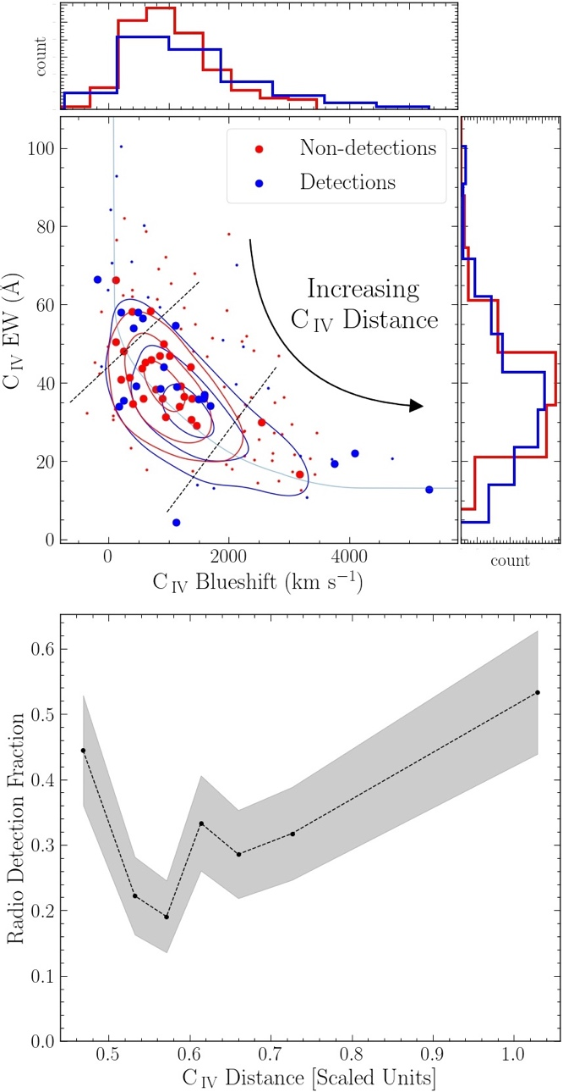environment tailored to reducing astronomical images, with many complex deconvolution algorithms built in. Because nobody else at Drexel had experience working with radio data, I learned all about the imaging process with limited remote assistance from Dr Kimball and spent much of my time working alone to understand these different imaging algorithms and how to apply them properly.

After performing imaging on the entire sample, I retrieved corresponding UV spectra for each target from the Sloan Digital Sky Survey (Schneider et al. 2010) and wrote Python code to read in and smooth each spectrum. The CIV equivalent width and blueshift, plotted in Figure 1 for all our targets, empirically represent the physical diversity of quasars (Richards et al. 2011). In particular, the equivalent width is anti-correlated with UV luminosity, which is necessary to drive an AGN wind, and the blueshift is an indicator of the strength of a successfully driven wind. I wrote code to combine these two parameters and define a new emission line metric, the “CIV distance,” illustrated in the top panel of Figure 1 (McCaffrey & Richards 2021). Quasars with low CIV distance are thought to have high black hole mass and low accretion rate, while high CIV distance indicates low black hole mass and high accretion rate (Giustini & Proga 2019). The bottom panel of Figure 1 shows that quasars with *either* high or low CIV distance generally produce more radio emission than those quasars in the middle of the distribution. This lack of a one-to-one trend suggests that *different* physical mechanisms produce radio emission at opposite ends of this parameter space, challenging the long-standing notion that radio emission in radio-quiet quasars has only a single origin. The CIV distance metric then acts as a proxy for which type of radio emission likely arises in which quasars.

Figure 1. Top: CIV emission line strength vs. blueshift (an indicator of the strength of a quasar’s wind). CIV distance combines the two parameters, defined as the scaled “distance” along the track starting from the upper left. Bottom: Fraction of quasars detected in the radio as a function of CIV distance. Sources with low/high distance are nominally detected at a higher rate than those with moderate CIV distance.

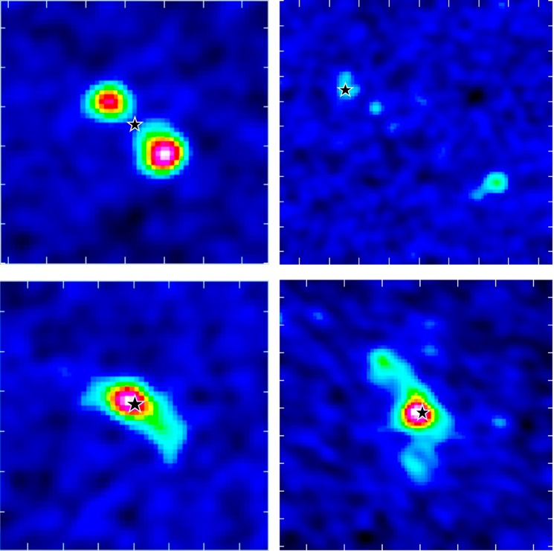My collaboration with Dr Kimball at NRAO on our first project led to her offering me a six-month co-op position continuing research in her lab. I used these six months to finish publishing a paper on our work with Professor Richards, and further used the imaging expertise I had developed at Drexel to lead a second related project with Dr Kimball. This time, I performed the same imaging process on a larger sample of 128 radio-quiet quasars. These observations were unique in that they were of quasars at much closer distance to Earth and were taken in the VLA’s highest resolution “A” configuration. This is important because since quasars are so distant, they are generally difficult to resolve and appear point-like, especially in radio images. But at the redshift of these quasars and given the observational details, I was able to image the quasars at galaxy-scale resolution, revealing for the first time detailed radio structure across a large homogeneous quasar sample. These new images (viz. Figure 2) provide new clues as to what physical mechanisms could be responsible for producing radio emission in quasars. Moreover, these images alone show that said radio emission does not come in a single form, in agreement with my previous findings with Professor Richards.

Figure 2. Example high-resolution radio images of quasars. Black stars indicate the position of the central black hole in each quasar. The top two possess linear jet-like structures, while the bottom two resemble diffuse emission characteristic of star formation or a wind spiraling off an accretion disk. These different morphologies suggest distinct origins of radio emission and are likely to be correlated with CIV distance.

Following my first co-op, I co-proposed with Professor Richards and Dr Kimball for time with the VLA in the Spring of 2022, where we have been fully allocated a total of ~33 hours of telescope time. With this time, we will re-analyze quasars from the first project I partook in, but at much higher resolution, allowing us to obtain detailed radio images of quasars like in Figure 2, and combine them with information contained in Figure 1. Combining complex morphologies through imaging with my spectroscopic analysis will allow us to make physical sense of the interesting radio images we obtain, enabling a concrete step forward in our understanding of AGN physics.

My research experiences as an undergraduate have exhaustively shown me what a research career is like. I’ve begun working on a problem I knew nothing about, analyzed that problem through several research projects, and have even learned enough about the problem at hand to pursue further work. I’ve learned throughout these past 3 years that I want to commit the rest of my life to the never-ending problem-solving cycle that is a research career in astronomy.

**Reference:**

1. Giustini & Proga 2019, A&A, 630, A94
2. McCaffrey & Richards 2021, github.com/RichardsGroup/CIV_Distance
3. Panessa et al. 2019, NatureAstron., 3, 387
4. Richards et al. 2011, AJ, 141, 167
5. Sandage 1965, ApJ, 141, 1560
6. Schneider et al. 2010, AJ, 139, 2360

